Early Bird Menu
Menu
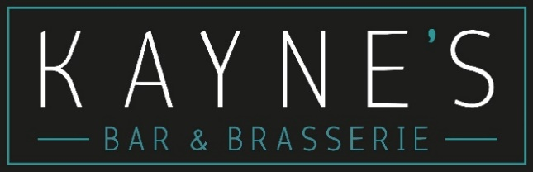
Monday – Thursday 4-6pm
2 Course €26.00 / 3 Courses €29.50
Add a glass of house wine or beer €5

Starters
Soup of the Day (A) (Allergens available on a daily basis)

Wild Atlantic Way Seafood Chowder (A)
Scented with Pastis and Fennel (Molluscs, Crustaceans, Fish, Celery, Milk, Sulphites, Wheat)

Crispy Gubbeen Chorizo Salad (A)
Toasted Smoked Almonds, Sundried Tomatoes, Pickled Balsamic Onions, Crunchy Herb Croutons, Seasonal Leaves, Wholegrain Mustard and Honey Dressing
(Wheat, Milk, Mustard, Almonds, Sulphites)

Mains
Grilled Fillets of Seabass
Cassoulet of Cannellini Beans, Gubbeen Chorizo, Smoked Paprika,
Slow Cooked Vine Tomatoes. Rocket and Almond Pesto
(Wheat, Sulphites, Almonds, Milk, Fish)

Kayne’s Smash Burger with BBQ Brisket (A)
2 x 3oz Beef Patties, Slow Cooked Whiskey BBQ Beef Brisket, Baby Gem Lettuce, Beef Tomato, Smoked Provolone Cheese, Garlic Mayo, Toasted Bap, Crispy Fries
(Wheat, Milk, Sesame, Sulphites)

Sri Lankan Style Ceylon Curry (A)
Medium Spiced Curry infused with Green Chilli, Coconut and Tamarind.
Chickpeas, Spinach, Onions, Cashews. Braised Coconut Rice.
Chutney & Flatbread
(Wheat, Sesame, Cashews)
Vegan or Chicken options available

Parmesan Crusted Chicken (A)
Marinated Chicken Breast in a Golden Parmesan Crumb. Pesto alla Trapanese, Saffron Braised Baby Potatoes, Marinated Cherry Tomatoes, Aged Balsamic
(Wheat, Milk, Almonds, Egg)

Creamy Risotto Verde (A)
Basil, Fennel, Petit Pois, Samphire, Spinach, Broad Beans, Chablis,
Parmesan and Mascarpone. Toasted Garlic Sourdough
(Vegan Option Available)
(Sulphites, Milk, Wheat)

Desserts
Strawberry & Lemon Eton Mess
Strawberry Compote, Lemon Curd, Whipped Cream & Crushed Meringue
(Egg, Milk)

Classic Spiced Apple Tarte Tatin (A)
Crème Anglaise & French Vanilla Ice-Cream (Milk, Egg, Wheat)

Dessert of the Day – Ask Server for details & allergens

House Selection of Ice-Creams (3 scoops) (A) (Milk, Wheat)

