

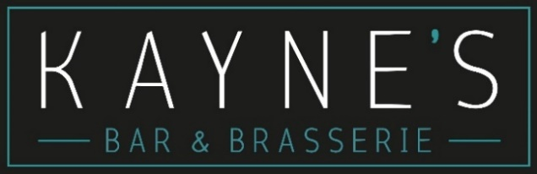

Table D’hote Menu Menu

€40 Per Person

Including Tea / Coffee

A = Adaptable to Gluten Free

Seasonal Vegetables €3.50

Potato of the day €3.50

Portion of fries €3.00

Sweet Potato Fries €4.50

Truffle Aioli & Parmesan Fries €5.50

Braised Coconut Rice €3.50

Seasonal Side Salad €3.50

**Desserts**

**Strawberry & Lemon Eton Mess**

Strawberry Compote, Lemon Curd, Whipped Cream & Crushed Meringue

(Egg, Milk)

**Classic Spiced Apple Tarte Tatin (A)**

Crème Anglaise & French Vanilla Ice-Cream

(Milk, Egg, Wheat)

**Rich Chocolate Delice**

Crunchy Chocolate Biscuit Base, Homemade Calypso Coffee Ice-Cream

**House Selection of Ice-Creams** (3 scoops) (A)

(Milk, Wheat)

**Mains**

**Pan Seared 10 oz Cronin's Rib Eye Steak** (A) (€10 supplement)

Sautéed Garlic Wild Mushrooms, Confit Shallot, Roast Vine Tomato, Crispy Fries &

a Choice of; Pepper & Whiskey Café au Lait / Café Du Paris Butter

(Wheat, Milk, Egg, Sulphites)

**Parmesan Crusted Chicken** (A)

Marinated Chicken Breast in a Golden Parmesan Crumb. Pesto alla Trapanese, Saffron Braised Baby Potatoes,

Marinated Cherry Tomatoes, Aged Balsamic

(Wheat, Milk, Almonds, Egg)

**Slow Cooked Ham Hock & Leek Pie**

Creamy Cider Reduction with Dijon, Shallots & Thyme, Golden Puff Pastry Lid

Traditional Colcannon

(Wheat, Milk, Mustard, Sulphites)

**Kayne’s Smash Burger with BBQ Brisket** (A)

2 x 3oz Beef Patties, Slow Cooked Whiskey BBQ Beef Brisket,

Baby Gem Lettuce, Beef Tomato, Smoked Provolone Cheese,

Garlic Mayo, Toasted Blaa, Crispy Fries

(Wheat, Milk, Sesame, Sulphites)

**Creamy Risotto Verde** (A)

Basil, Fennel, Petit Pois, Samphire, Spinach, Broad Beans, Chablis,

Parmesan, Mascarpone.

Toasted Garlic Sourdough (Vegan Option Available)

(Sulphites, Milk, Wheat)

**Grilled Fillets of Seabass**

Cassoulet of Cannellini Beans, Gubbeen Chorizo, Smoked Paprika,

Slow Cooked Vine Tomatoes. Rocket and Almond Pesto

(Wheat, Sulphites, Almonds, Milk, Fish)

**Starters**

**Soup of the Day (A)** (Allergens available on a daily basis)

**Dingle Goats Cheese Bruschetta** (A)

Roast Pimentos, Confit Garlic, Extra Virgin Olive Oil, Basil & Almond Pesto, Crusty Sourdough, Dressed Rocket (Wheat, Milk, Nuts)

**Wild Atlantic Way Seafood Chowder (A)**

Scented with Pastis and Fennel (Molluscs, Crustaceans, Fish, Celery, Milk, Sulphites, Wheat)

**Crispy Gubbeen Chorizo Salad** (A)

Toasted Smoked Almonds, Sundried Tomatoes, Pickled Balsamic Onions, Crunchy Herb Croutons, Seasonal Leaves, Wholegrain Mustard and Honey Dressing

(Wheat, Milk, Mustard, Almonds, Sulphites)

**Spiced Coconut & Sesame Crumbed Prawns (A) (€4 Supplement)**

Pineapple Salsa, Lime Aioli, Sweet Chilli Sauce

(Wheat, Milk, Egg, Crustaceans, Sesame)

